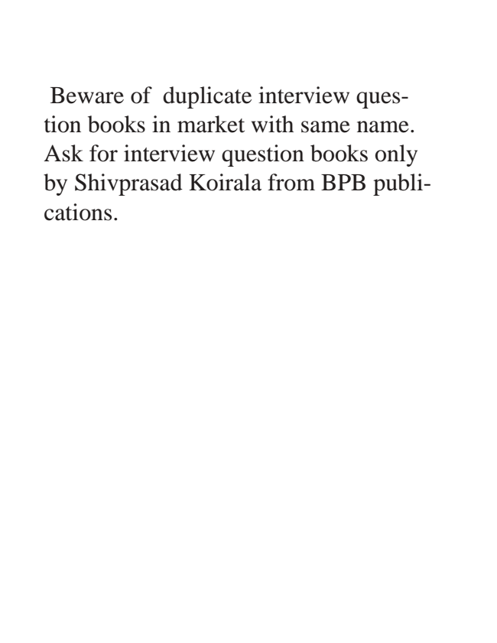

Beware of duplicate interview ques- tion books in market with same name. Ask for interview question books only by Shivprasad Koirala from BPB publi- cations.

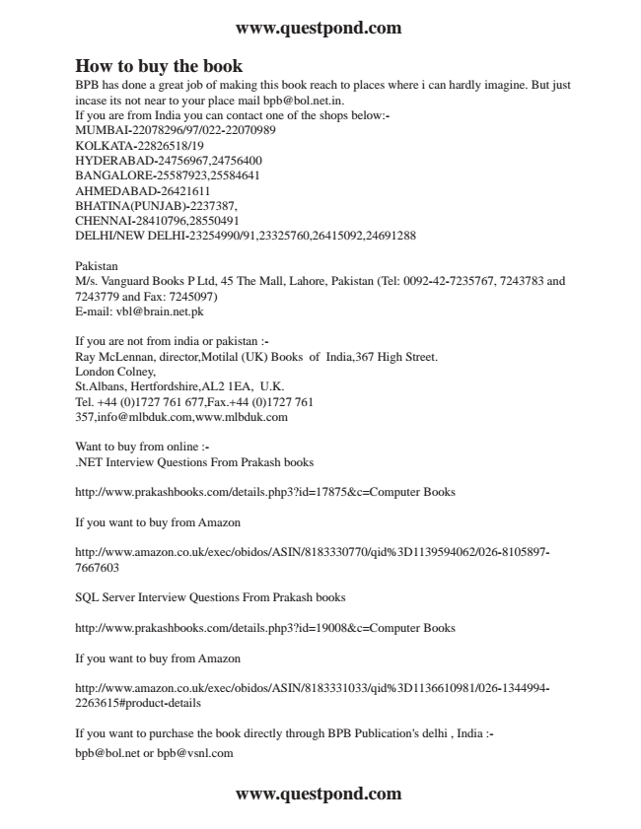

**www.questpond.com**

How to buy the book BPB has done a great job of making this book reach to places where i can hardly imagine. But just incase its not near to your place mail bpb@bol.net.in. If you are from India you can contact one of the shops below:- MUMBAI-22078296/97/022-22070989 KOLKATA-22826518/19 HYDERABAD-24756967,24756400 BANGALORE-25587923,25584641 AHMEDABAD-26421611 BHATINA(PUNJAB)-2237387, CHENNAI-28410796,28550491 DELHI/NEW DELHI-23254990/91,23325760,26415092,24691288

Pakistan M/s. Vanguard Books P Ltd, 45 The Mall, Lahore, Pakistan (Tel: 0092-42-7235767, 7243783 and 7243779 and Fax: 7245097) E-mail: vbl@brain.net.pk

If you are not from india or pakistan :- Ray McLennan, director,Motilal (UK) Books of India,367 High Street. London Colney, St.Albans, Hertfordshire,AL2 1EA, U.K. Tel. +44 (0)1727 761 677,Fax.+44 (0)1727 761 357,info@mlbduk.com,www.mlbduk.com

Want to buy from online :- .NET Interview Questions From Prakash books

http://www.prakashbooks.com/details.php3?id=17875&c=Computer Books

If you want to buy from Amazon

http://www.amazon.co.uk/exec/obidos/ASIN/8183330770/qid%3D1139594062/026-8105897- 7667603

SQL Server Interview Questions From Prakash books

http://www.prakashbooks.com/details.php3?id=19008&c=Computer Books

If you want to buy from Amazon

http://www.amazon.co.uk/exec/obidos/ASIN/8183331033/qid%3D1136610981/026-1344994- 2263615#product-details

If you want to purchase the book directly through BPB Publication's delhi , India :- bpb@bol.net or bpb@vsnl.com

**www.questpond.com**

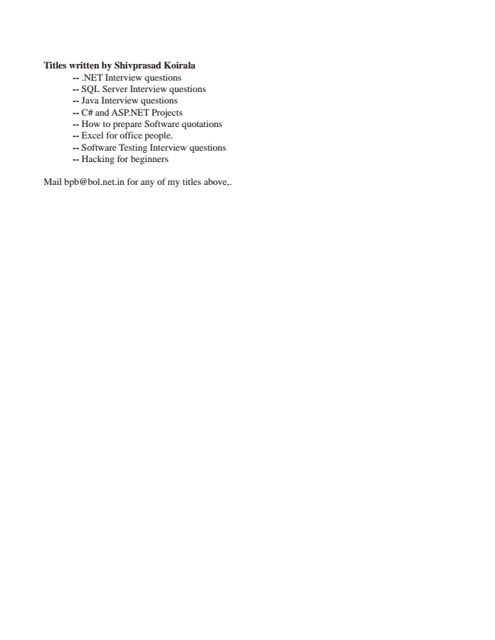

**Titles written by Shivprasad Koirala**

-- .NET Interview questions -- SQL Server Interview questions -- Java Interview questions -- C# and ASP.NET Projects -- How to prepare Software quotations -- Excel for office people. -- Software Testing Interview questions -- Hacking for beginners

Mail bpb@bol.net.in for any of my titles above,.

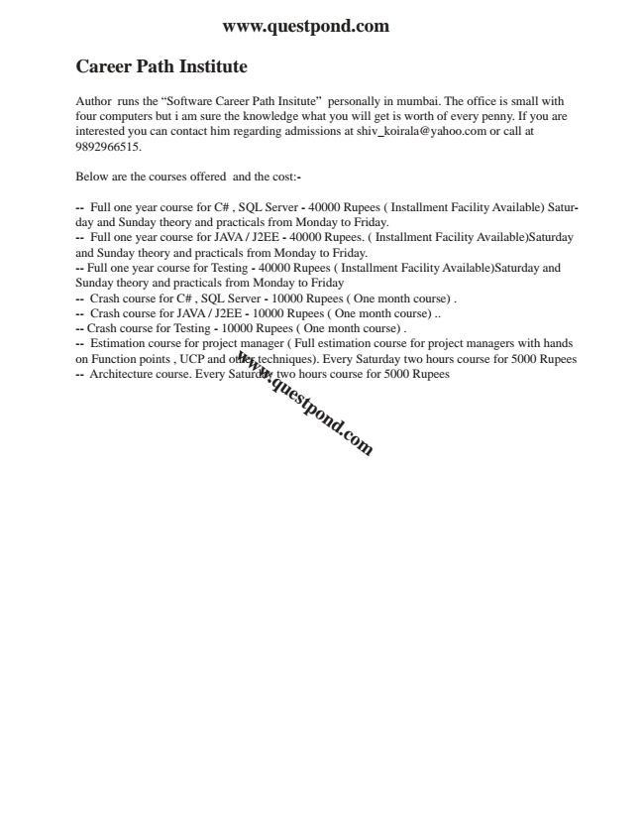

**www.questpond.com**

**Career Path Institute**

Author runs the “Software Career Path Insitute” personally in mumbai. The office is small with four computers but i am sure the knowledge what you will get is worth of every penny. If you are interested you can contact him regarding admissions at shiv_koirala@yahoo.com or call at 9892966515.

Below are the courses offered and the cost:-

-- Full one year course for C# , SQL Server - 40000 Rupees ( Installment Facility Available) Satur- day and Sunday theory and practicals from Monday to Friday. -- Full one year course for JAVA / J2EE - 40000 Rupees. ( Installment Facility Available)Saturday and Sunday theory and practicals from Monday to Friday. -- Full one year course for Testing - 40000 Rupees ( Installment Facility Available)Saturday and Sunday theory and practicals from Monday to Friday -- Crash course for C# , SQL Server - 10000 Rupees ( One month course) . -- Crash course for JAVA / J2EE - 10000 Rupees ( One month course) .. -- Crash course for Testing - 10000 Rupees ( One month course) . -- on -- Architecture Estimation Function points course course. , UCP for Every project and Saturday other w

manager w w techniques). .q two u ( e s Full hours tp o estimation n Every d course .c o Saturday m for course 5000 two for Rupees

hours project course managers for 5000 with Rupees hands

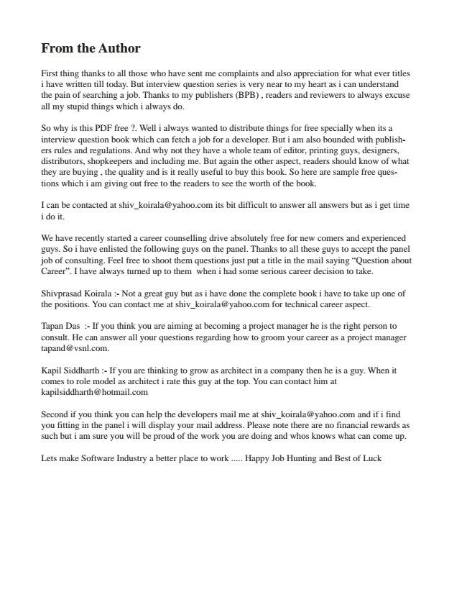

**From the Author**

First thing thanks to all those who have sent me complaints and also appreciation for what ever titles i have written till today. But interview question series is very near to my heart as i can understand the pain of searching a job. Thanks to my publishers (BPB) , readers and reviewers to always excuse all my stupid things which i always do.

So why is this PDF free ?. Well i always wanted to distribute things for free specially when its a interview question book which can fetch a job for a developer. But i am also bounded with publish- ers rules and regulations. And why not they have a whole team of editor, printing guys, designers, distributors, shopkeepers and including me. But again the other aspect, readers should know of what they are buying , the quality and is it really useful to buy this book. So here are sample free ques- tions which i am giving out free to the readers to see the worth of the book.

I can be contacted at shiv_koirala@yahoo.com its bit difficult to answer all answers but as i get time i do it.

We have recently started a career counselling drive absolutely free for new comers and experienced guys. So i have enlisted the following guys on the panel. Thanks to all these guys to accept the panel job of consulting. Feel free to shoot them questions just put a title in the mail saying “Question about Career”. I have always turned up to them when i had some serious career decision to take.

Shivprasad Koirala :- Not a great guy but as i have done the complete book i have to take up one of the positions. You can contact me at shiv_koirala@yahoo.com for technical career aspect.

Tapan Das :- If you think you are aiming at becoming a project manager he is the right person to consult. He can answer all your questions regarding how to groom your career as a project manager tapand@vsnl.com.

Kapil Siddharth :- If you are thinking to grow as architect in a company then he is a guy. When it comes to role model as architect i rate this guy at the top. You can contact him at kapilsiddharth@hotmail.com

Second if you think you can help the developers mail me at shiv_koirala@yahoo.com and if i find you fitting in the panel i will display your mail address. Please note there are no financial rewards as such but i am sure you will be proud of the work you are doing and whos knows what can come up.

Lets make Software Industry a better place to work ..... Happy Job Hunting and Best of Luck

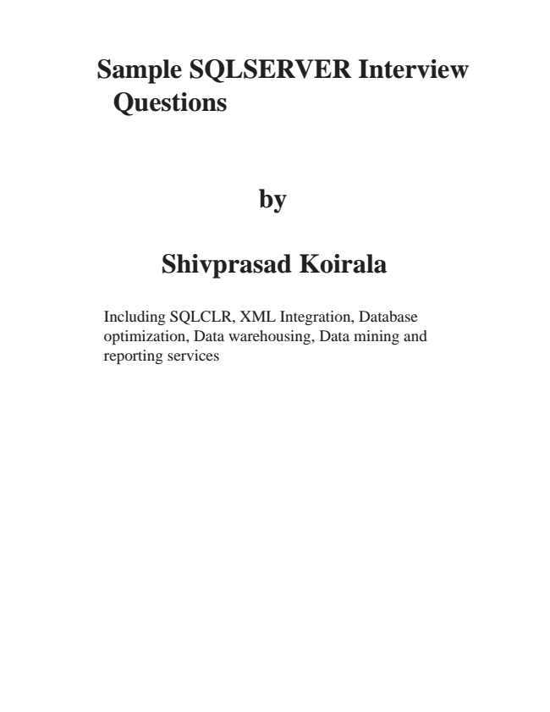

**Sample SQLSERVER Interview**

**Questions**

**by**

**Shivprasad Koirala**

Including SQLCLR, XML Integration, Database optimization, Data warehousing, Data mining and reporting services

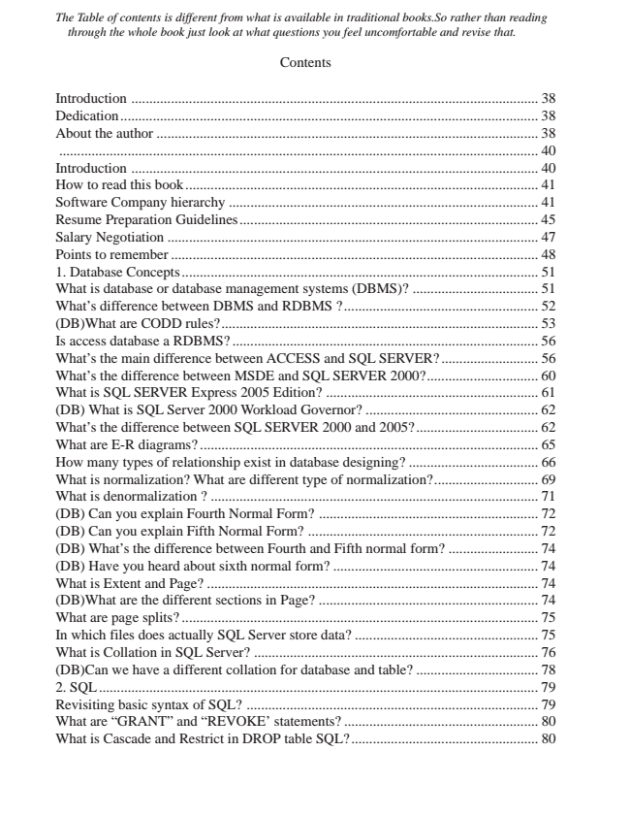

*The Table of contents is different from what is available in traditional books.So rather than reading*

*through the whole book just look at what questions you feel uncomfortable and revise that.*

Contents

Introduction ................................................................................................................. 38 Dedication .................................................................................................................... 38 About the author .......................................................................................................... 38 ..................................................................................................................................... 40 Introduction ................................................................................................................. 40 How to read this book.................................................................................................. 41 Software Company hierarchy ...................................................................................... 41 Resume Preparation Guidelines................................................................................... 45 Salary Negotiation ....................................................................................................... 47 Points to remember ...................................................................................................... 48 1. Database Concepts ................................................................................................... 51 What is database or database management systems (DBMS)? ................................... 51 What’s difference between DBMS and RDBMS ?...................................................... 52 (DB)What are CODD rules?........................................................................................ 53 Is access database a RDBMS? ..................................................................................... 56 What’s the main difference between ACCESS and SQL SERVER? ........................... 56 What’s the difference between MSDE and SQL SERVER 2000?............................... 60 What is SQL SERVER Express 2005 Edition? ........................................................... 61 (DB) What is SQL Server 2000 Workload Governor? ................................................ 62 What’s the difference between SQL SERVER 2000 and 2005?.................................. 62 What are E-R diagrams? .............................................................................................. 65 How many types of relationship exist in database designing? .................................... 66 What is normalization? What are different type of normalization?............................. 69 What is denormalization ? ........................................................................................... 71 (DB) Can you explain Fourth Normal Form? ............................................................. 72 (DB) Can you explain Fifth Normal Form? ................................................................ 72 (DB) What’s the difference between Fourth and Fifth normal form? ......................... 74 (DB) Have you heard about sixth normal form? ......................................................... 74 What is Extent and Page? ............................................................................................ 74 (DB)What are the different sections in Page? ............................................................. 74 What are page splits? ................................................................................................... 75 In which files does actually SQL Server store data? ................................................... 75 What is Collation in SQL Server? ............................................................................... 76 (DB)Can we have a different collation for database and table? .................................. 78 2. SQL .......................................................................................................................... 79 Revisiting basic syntax of SQL? ................................................................................. 79 What are “GRANT” and “REVOKE’ statements? ...................................................... 80 What is Cascade and Restrict in DROP table SQL?.................................................... 80

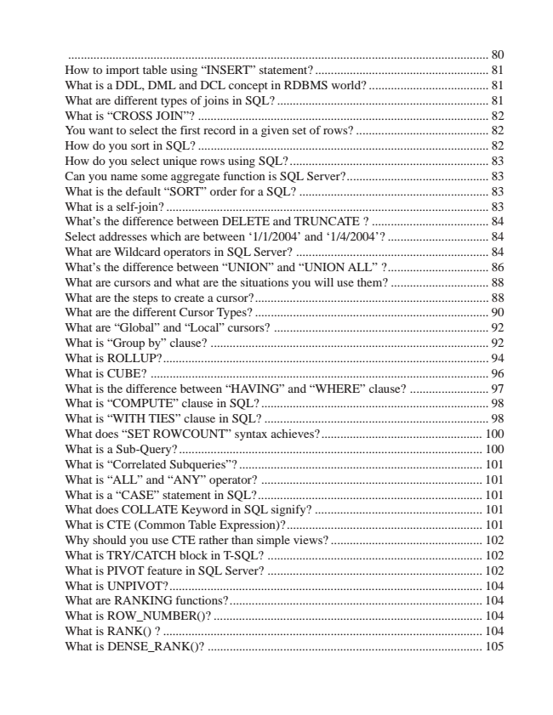

..................................................................................................................................... 80 How to import table using “INSERT” statement? ....................................................... 81 What is a DDL, DML and DCL concept in RDBMS world? ...................................... 81 What are different types of joins in SQL? ................................................................... 81 What is “CROSS JOIN”? ............................................................................................ 82 You want to select the first record in a given set of rows? .......................................... 82 How do you sort in SQL? ............................................................................................ 82 How do you select unique rows using SQL?............................................................... 83 Can you name some aggregate function is SQL Server?............................................. 83 What is the default “SORT” order for a SQL? ............................................................ 83 What is a self-join? ...................................................................................................... 83 What’s the difference between DELETE and TRUNCATE ? ..................................... 84 Select addresses which are between ‘1/1/2004’ and ‘1/4/2004’? ................................ 84 What are Wildcard operators in SQL Server? ............................................................. 84 What’s the difference between “UNION” and “UNION ALL” ?................................ 86 What are cursors and what are the situations you will use them? ............................... 88 What are the steps to create a cursor?.......................................................................... 88 What are the different Cursor Types? .......................................................................... 90 What are “Global” and “Local” cursors? .................................................................... 92 What is “Group by” clause? ........................................................................................ 92 What is ROLLUP?....................................................................................................... 94 What is CUBE? ........................................................................................................... 96 What is the difference between “HAVING” and “WHERE” clause? ......................... 97 What is “COMPUTE” clause in SQL? ........................................................................ 98 What is “WITH TIES” clause in SQL? ....................................................................... 98 What does “SET ROWCOUNT” syntax achieves?................................................... 100 What is a Sub-Query? ................................................................................................ 100 What is “Correlated Subqueries”? ............................................................................. 101 What is “ALL” and “ANY” operator? ...................................................................... 101 What is a “CASE” statement in SQL?....................................................................... 101 What does COLLATE Keyword in SQL signify? ..................................................... 101 What is CTE (Common Table Expression)?.............................................................. 101 Why should you use CTE rather than simple views? ................................................ 102 What is TRY/CATCH block in T-SQL? .................................................................... 102 What is PIVOT feature in SQL Server? .................................................................... 102 What is UNPIVOT?................................................................................................... 104 What are RANKING functions?................................................................................ 104 What is ROW_NUMBER()? ..................................................................................... 104 What is RANK() ? ..................................................................................................... 104 What is DENSE_RANK()? ....................................................................................... 105

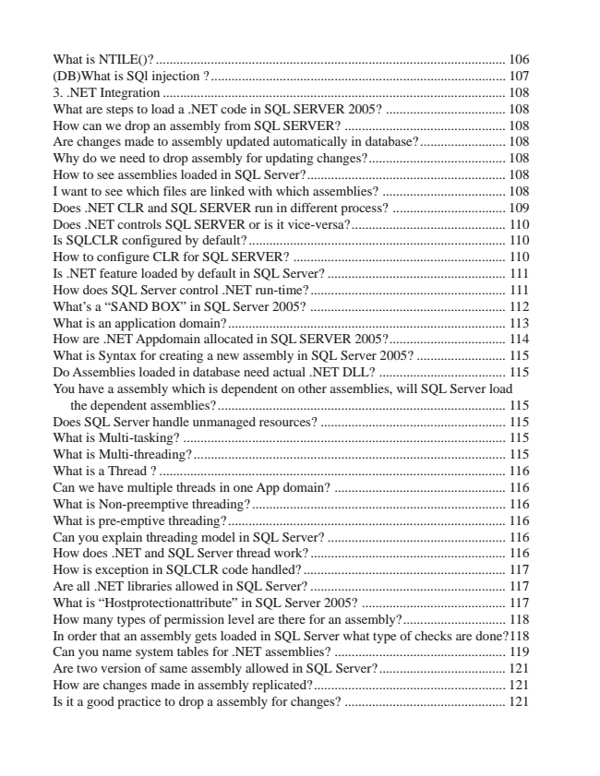

What is NTILE()? ...................................................................................................... 106 (DB)What is SQl injection ?...................................................................................... 107 3. .NET Integration .................................................................................................... 108 What are steps to load a .NET code in SQL SERVER 2005? ................................... 108 How can we drop an assembly from SQL SERVER? ............................................... 108 Are changes made to assembly updated automatically in database? ......................... 108 Why do we need to drop assembly for updating changes?........................................ 108 How to see assemblies loaded in SQL Server?.......................................................... 108 I want to see which files are linked with which assemblies? .................................... 108 Does .NET CLR and SQL SERVER run in different process? ................................. 109 Does .NET controls SQL SERVER or is it vice-versa?............................................. 110 Is SQLCLR configured by default? ........................................................................... 110 How to configure CLR for SQL SERVER? .............................................................. 110 Is .NET feature loaded by default in SQL Server? .................................................... 111 How does SQL Server control .NET run-time? ......................................................... 111 What’s a “SAND BOX” in SQL Server 2005? ......................................................... 112 What is an application domain?................................................................................. 113 How are .NET Appdomain allocated in SQL SERVER 2005?.................................. 114 What is Syntax for creating a new assembly in SQL Server 2005? .......................... 115 Do Assemblies loaded in database need actual .NET DLL? ..................................... 115 You have a assembly which is dependent on other assemblies, will SQL Server load

the dependent assemblies? .................................................................................... 115 Does SQL Server handle unmanaged resources? ...................................................... 115 What is Multi-tasking? .............................................................................................. 115 What is Multi-threading? ........................................................................................... 115 What is a Thread ? ..................................................................................................... 116 Can we have multiple threads in one App domain? .................................................. 116 What is Non-preemptive threading? .......................................................................... 116 What is pre-emptive threading? ................................................................................. 116 Can you explain threading model in SQL Server? .................................................... 116 How does .NET and SQL Server thread work? ......................................................... 116 How is exception in SQLCLR code handled? ........................................................... 117 Are all .NET libraries allowed in SQL Server? ......................................................... 117 What is “Hostprotectionattribute” in SQL Server 2005? .......................................... 117 How many types of permission level are there for an assembly?.............................. 118 In order that an assembly gets loaded in SQL Server what type of checks are done?118 Can you name system tables for .NET assemblies? .................................................. 119 Are two version of same assembly allowed in SQL Server?..................................... 121 How are changes made in assembly replicated?........................................................ 121 Is it a good practice to drop a assembly for changes? ............................................... 121

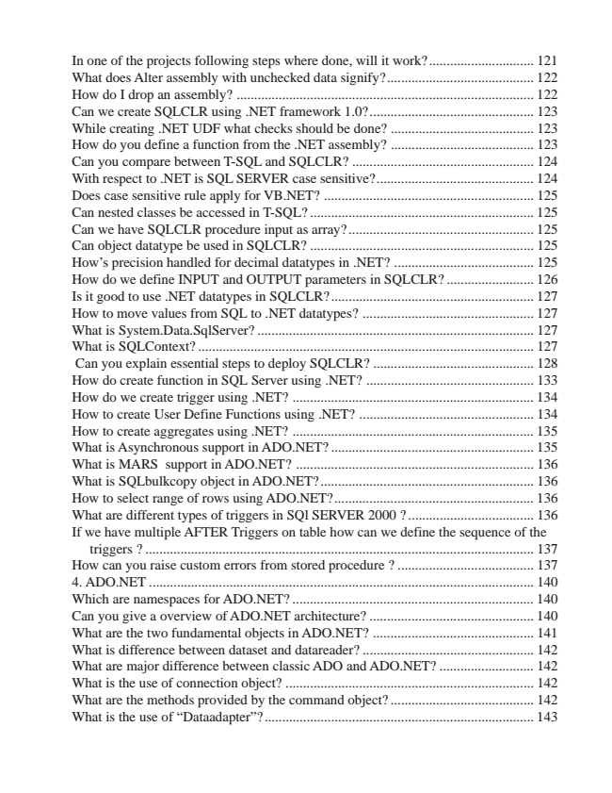

In one of the projects following steps where done, will it work?.............................. 121 What does Alter assembly with unchecked data signify?.......................................... 122 How do I drop an assembly? ..................................................................................... 122 Can we create SQLCLR using .NET framework 1.0?............................................... 123 While creating .NET UDF what checks should be done? ......................................... 123 How do you define a function from the .NET assembly? ......................................... 123 Can you compare between T-SQL and SQLCLR? .................................................... 124 With respect to .NET is SQL SERVER case sensitive?............................................. 124 Does case sensitive rule apply for VB.NET? ............................................................ 125 Can nested classes be accessed in T-SQL? ................................................................ 125 Can we have SQLCLR procedure input as array? ..................................................... 125 Can object datatype be used in SQLCLR? ................................................................ 125 How’s precision handled for decimal datatypes in .NET? ........................................ 125 How do we define INPUT and OUTPUT parameters in SQLCLR? ......................... 126 Is it good to use .NET datatypes in SQLCLR? .......................................................... 127 How to move values from SQL to .NET datatypes? ................................................. 127 What is System.Data.SqlServer? ............................................................................... 127 What is SQLContext? ................................................................................................ 127 Can you explain essential steps to deploy SQLCLR? .............................................. 128 How do create function in SQL Server using .NET? ................................................ 133 How do we create trigger using .NET? ..................................................................... 134 How to create User Define Functions using .NET? .................................................. 134 How to create aggregates using .NET? ..................................................................... 135 What is Asynchronous support in ADO.NET? .......................................................... 135 What is MARS support in ADO.NET? .................................................................... 136 What is SQLbulkcopy object in ADO.NET?............................................................. 136 How to select range of rows using ADO.NET?......................................................... 136 What are different types of triggers in SQl SERVER 2000 ? .................................... 136 If we have multiple AFTER Triggers on table how can we define the sequence of the

triggers ? ............................................................................................................... 137 How can you raise custom errors from stored procedure ? ....................................... 137 4. ADO.NET .............................................................................................................. 140 Which are namespaces for ADO.NET? ..................................................................... 140 Can you give a overview of ADO.NET architecture? ............................................... 140 What are the two fundamental objects in ADO.NET? .............................................. 141 What is difference between dataset and datareader? ................................................. 142 What are major difference between classic ADO and ADO.NET? ........................... 142 What is the use of connection object? ....................................................................... 142 What are the methods provided by the command object? ......................................... 142 What is the use of “Dataadapter”? ............................................................................. 143